**Ali Abbas Khan**

**24-CP-27**

**PF Lab No 7**

**Date 24-02-2025**

**Marks 8 out of 8**

**Task 01**

**Question No. 01**

Write a program that uses a for loop to print all even numbers between 1 and 20.

**Codding and Output**

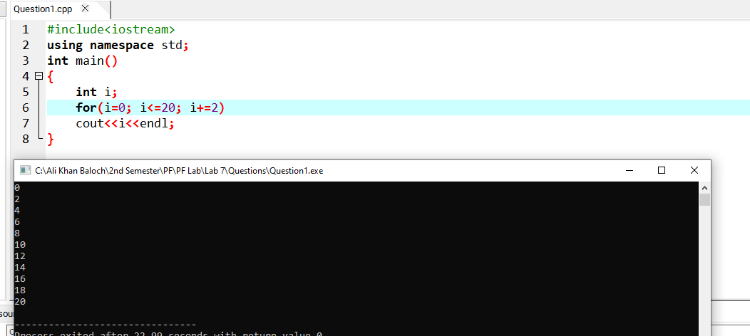

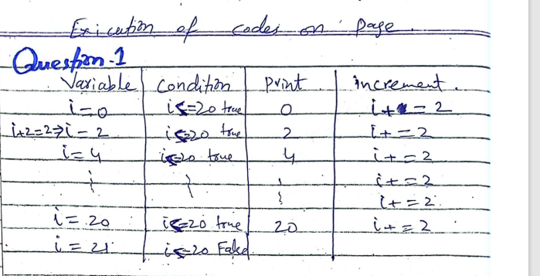

**Question No. 02**

Write a program to calculate the sum of the first 10 odd numbers and first 10 even numbers.

**Codding and Output**

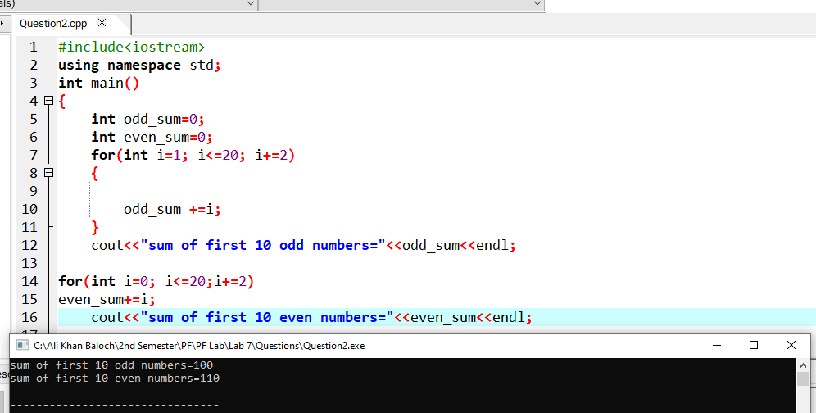

**Question No. 03**

Write a program to calculate the square and cube of first ten even numbers.

**Codding and Output**

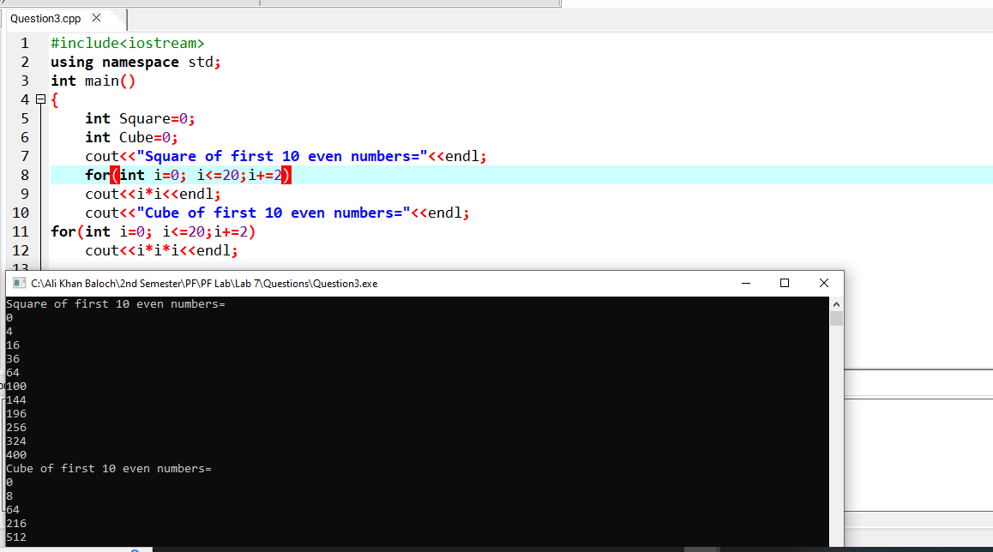

**Question No. 04**

Write a program that uses for loop to print the table of a number entered by the user.

**Codding and Output**

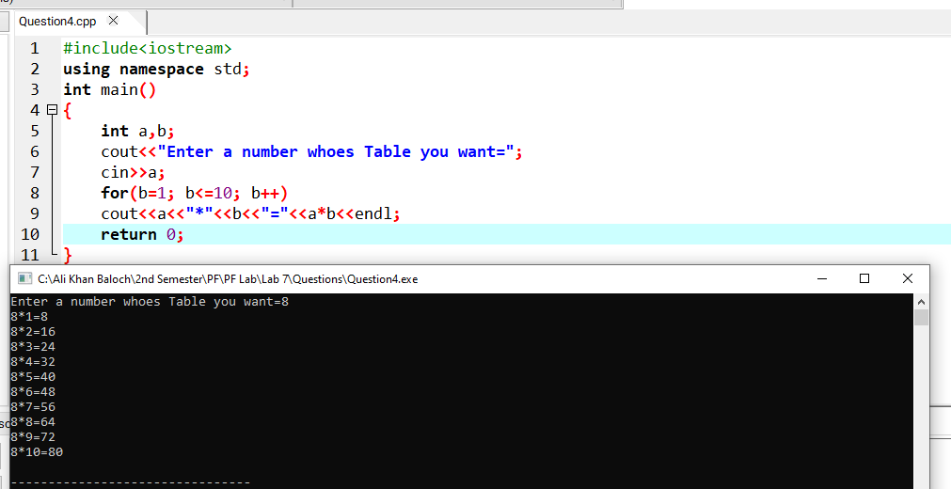

**Question No. 05**

Write a program that uses for loop to print natural numbers 1 to 10 in descending order

**Codding and Output**

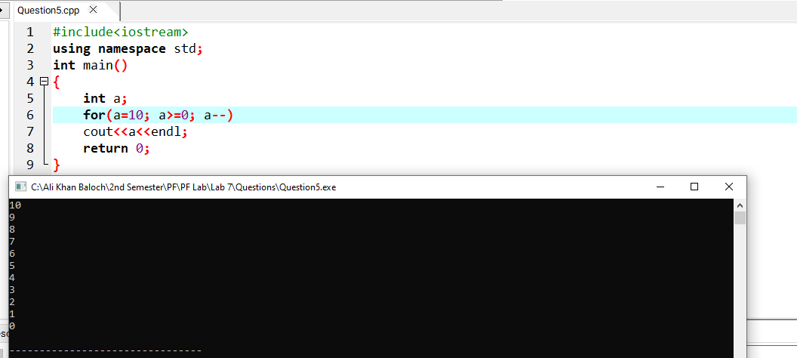

**Question No. 06**

Write a program to calculate whether the number entered is prime or not.

**Codding and Output**

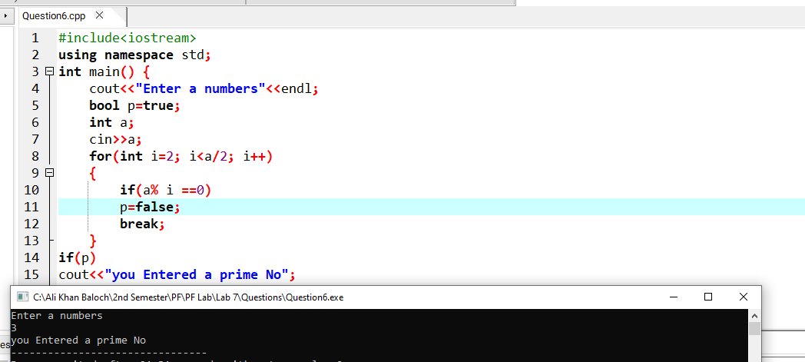

**Question No. 07**

Write a program to calculate factorial of a number entered by user.

**Codding and Output**

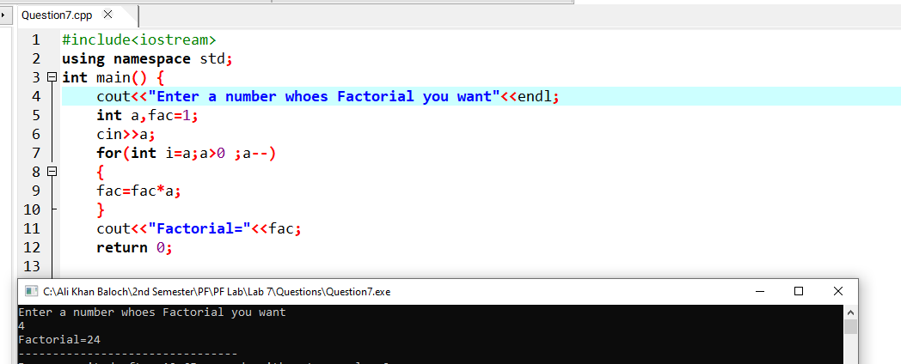

**Question No. 08**

Write a C++ program to print all numbers between a and b (a and b inclusive) using for loops

**Codding and Output**

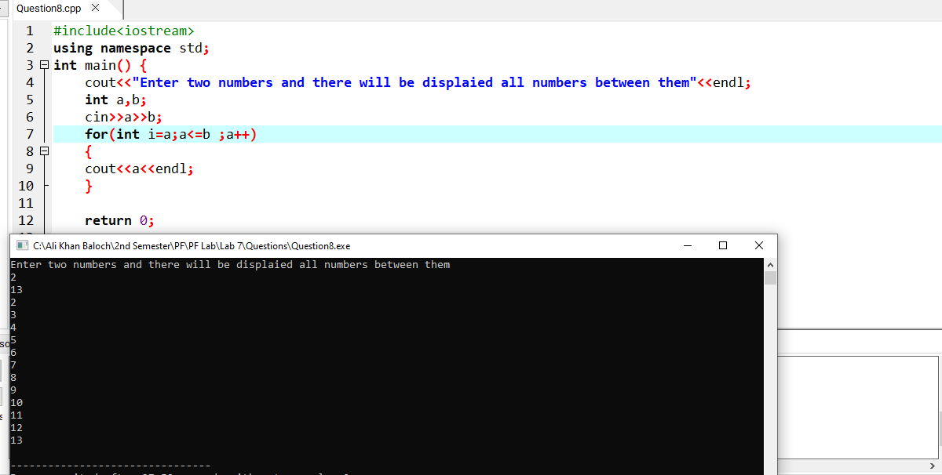

**Question No. 09**

Write a C++ program to solve the following series: 5 + 8 + 11 + .... + 50

**Codding and Output**



